miraculousness of consciousness
this is the metaquestion(or metaproblem) of consciousness: “why do we ask questions about the miracle of consciousness”. it feels miraculous, but it may not be so in fact.
when we observe the material world, it feels impossible for it to create the subjective feelings inside me. i can knock on the table, and be perplexed that something like it could possibly create my inner world. i divide existence into two equal halves: the outer material world, and the inner world of feelings.
this is the view in my mind:
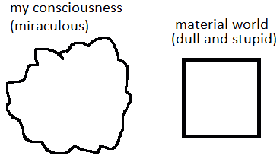
in this view, the Material world can’t create Feelings (my consciousness), but it’s a wrong view.
this is the correct view:
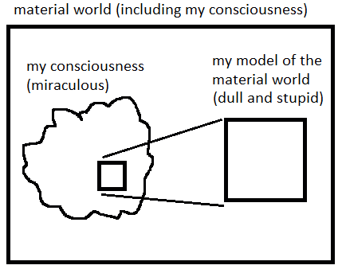
i can’t expect the creation of my mind from the thing that i called “material world” initially. that whole thing is, in turn, created by my mind, and exists inside of my mind.
even the most precise model of the world (which is material) will leave its builder feel a miracle of himself. because no model can encompass its builder himself:
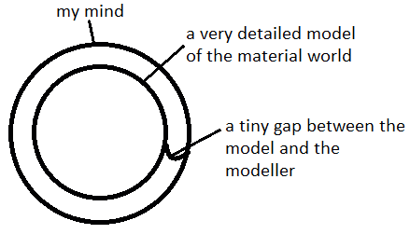
because of the tiny gap which makes the model less than its builder - the consciousness (or feelings, or mind) will feel miraculous and inexplicable. you can explain it, by studying neuroscience, but still you will feel that you’re “not really explaining This” (referring to yourself): all the explanations are deemed to stay inside the model of the world.
